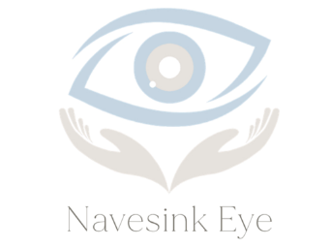
Patient Communication Consent – Text Messaging
To enhance our communication and better serve you, we offer text message reminders for appointments, billing, and general office updates.
Please read and sign below to authorize us to contact you via text message.
I consent to receive text messages from Navesink Eye related to:
- Appointment reminders
- Billing notifications, including outstanding balances
- General office updates (e.g., holiday hours, closures)
- Prescription or care coordination notices (no sensitive health information will be included unless through a secure, HIPAA-compliant platform)
I understand:
- Text messages may be sent using an automated system.
- No sensitive medical information (PHI) will be sent via unsecured text.
- Message and data rates may apply depending on my plan.
- I can opt out at any time by notifying the office or replying “STOP” to a text message.

For Adult Patients (18 and over):
Mobile Number: ___________________________________
Patient Name (Printed): _____________________________
Patient Signature: __________________________________
Date: ___________________
For Minor Patients (Under 18):
I am the parent or legal guardian of the patient named below. I authorize Navesink Eye to send text messages to me regarding the minor’s care, billing, and appointments as described above.
Minor’s Name: _____________________________________
Parent/Guardian Name: ______________________________
Mobile Number for Texts: _____________________________
Signature of Parent/Guardian: _________________________
Date: ___________________

